CO 2 DEBUGGING
NAME: D JESHURUN SILAS
REG NO : 192525324

- BUGGY CODE IN POP
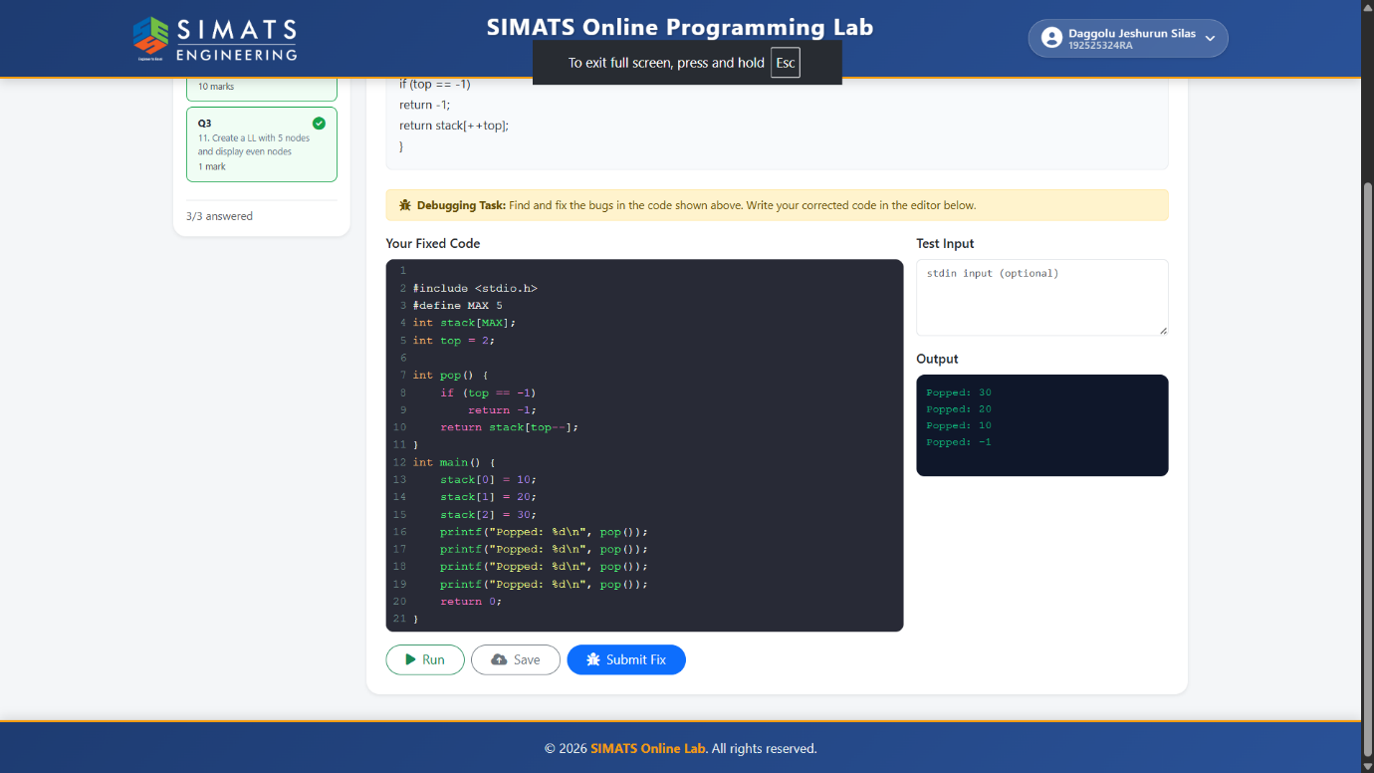
- BUGGY CODE IN UNDERFLOW OPERATIONS
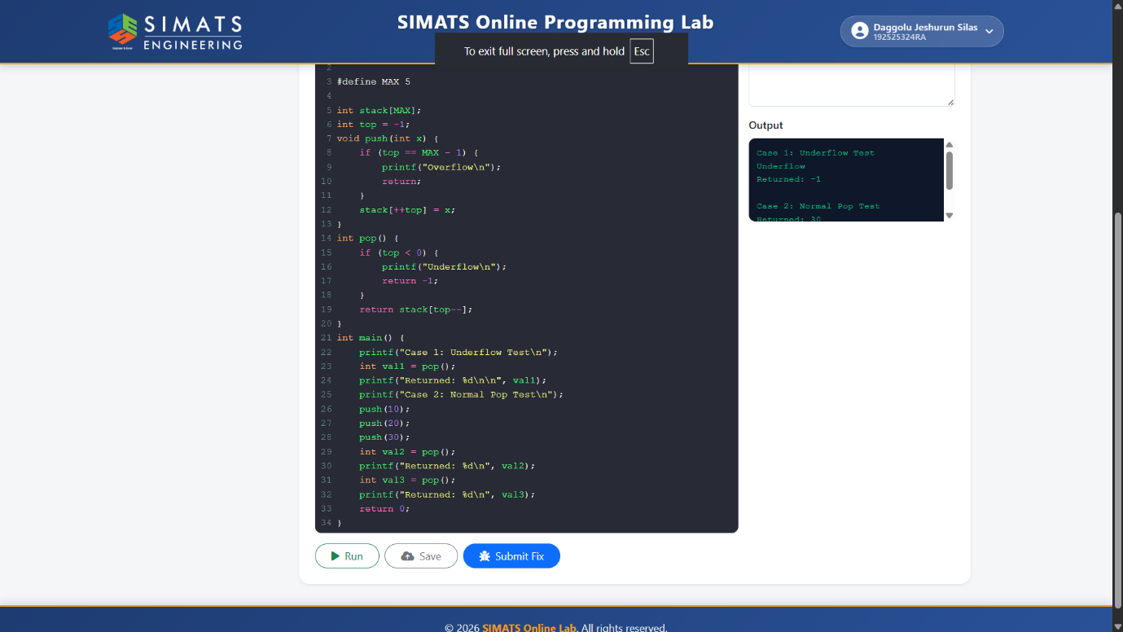

- CREATE A LINKED LIST AND DISPLAY 5 EVEN NODES
